Explanation of the Context based item recommendation model

Importing Necessary Libraries:
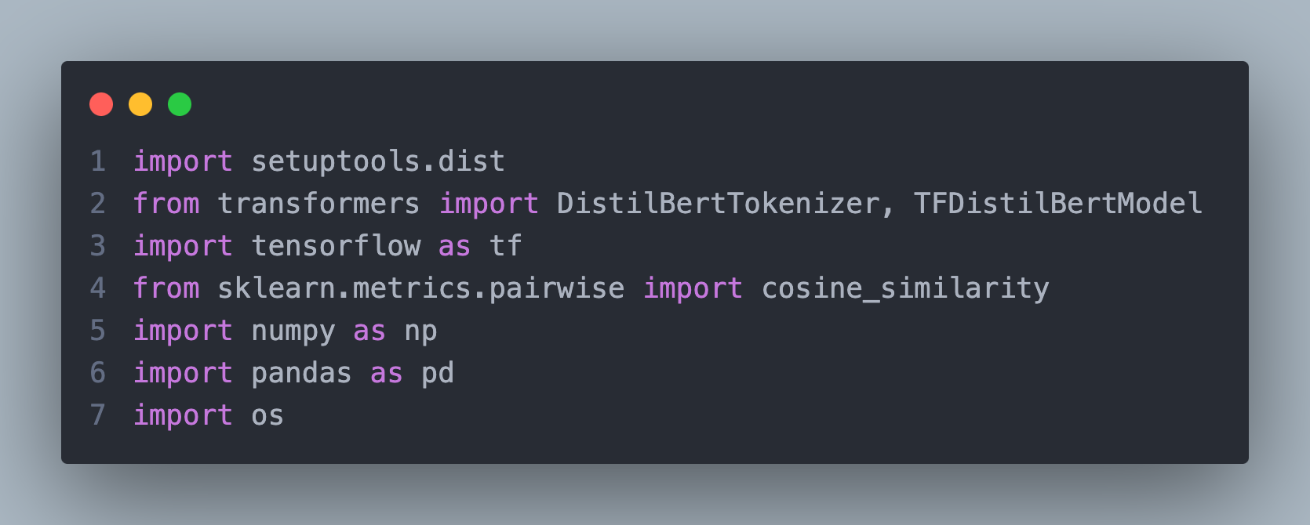
This kernel imports essential Python libraries for natural language processing, machine learning, and file handling:
- setuptools.dist: Manages dependencies.
- transformers: Provides pre-trained models like DistilBERT for generating embeddings.
- tensorflow: Used for tensor operations and running the DistilBERT model.
- sklearn.metrics.pairwise: Calculates cosine similarity between embeddings.
- numpy: Handles numerical operations.
- pandas: Manages structured data.
- os: Handles directory and file paths.

Loading Data:
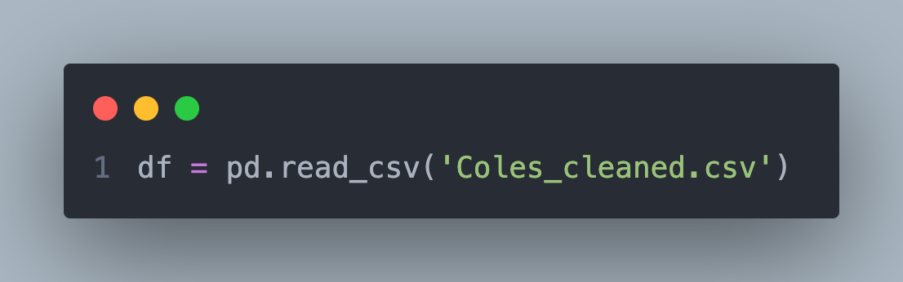
Loads the dataset containing cleaned product information from the Coles supermarket into a Pandas DataFrame.

Initializing the DistilBERT Model:
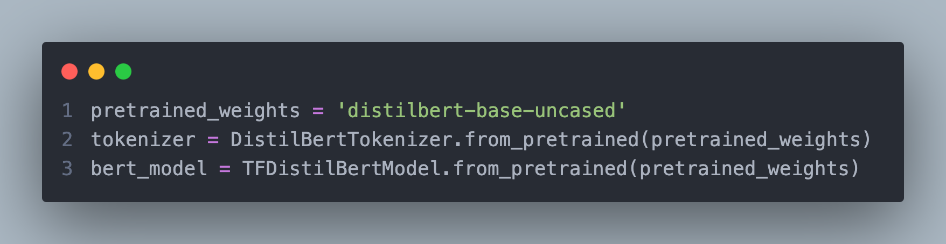
- DistilBertTokenizer: Prepares text data for the DistilBERT model.
- TFDistilBertModel: Loads the pre-trained DistilBERT model for generating text embeddings.
- Both models use the weights distilbert-base-uncased.

Embedding Generation for Product Names:
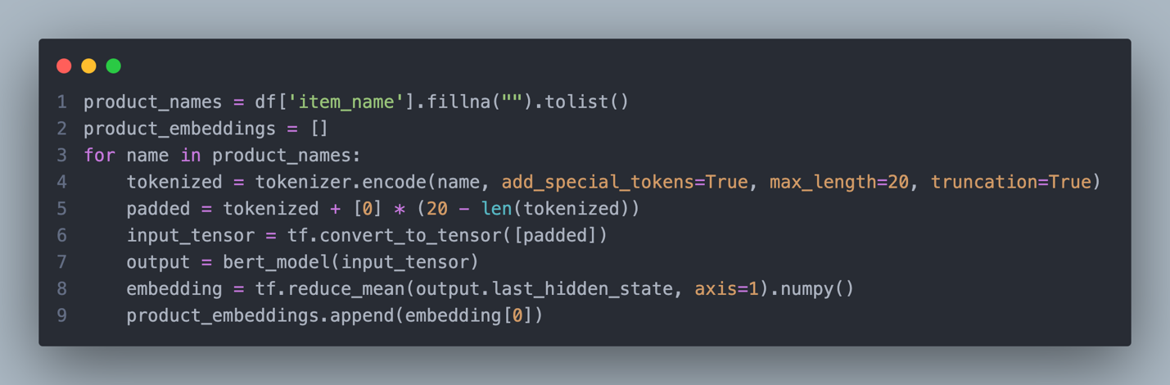
- Extracts product names and generates embeddings using the DistilBERT model.
- Each product name is tokenized, padded to a fixed length (20), converted to tensors, and passed through DistilBERT.
- Mean pooling is applied to generate a single embedding for each product name.

Batch Processing for Efficiency:
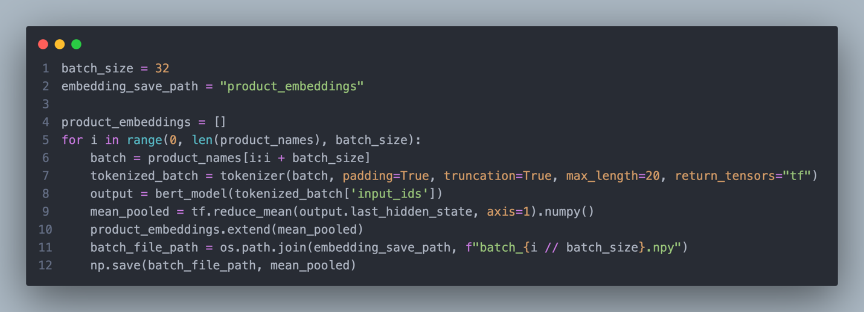
- Processes product names in batches of size 32 for faster computation.
- Tokenizes and generates embeddings for each batch.
- Saves embeddings for each batch as .npy files in the specified directory.

Saving and Loading all Embeddings:
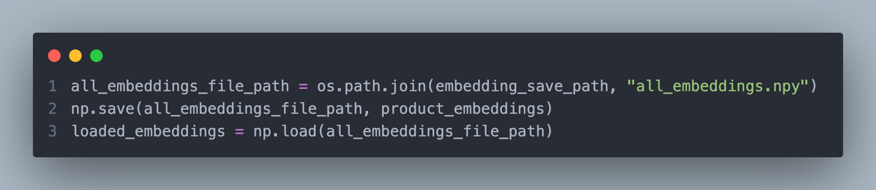
- Combines and saves all embeddings into a single .npy file for future use.
- Loads the saved embeddings from the file for further processing.

Compute Similarity Matrix:
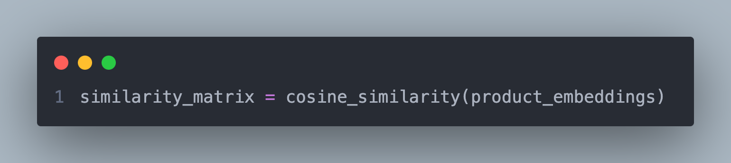
- Computes pairwise cosine similarity between product embeddings.
- The result is a similarity matrix where each entry represents the similarity between two products.

Product Recommendation:
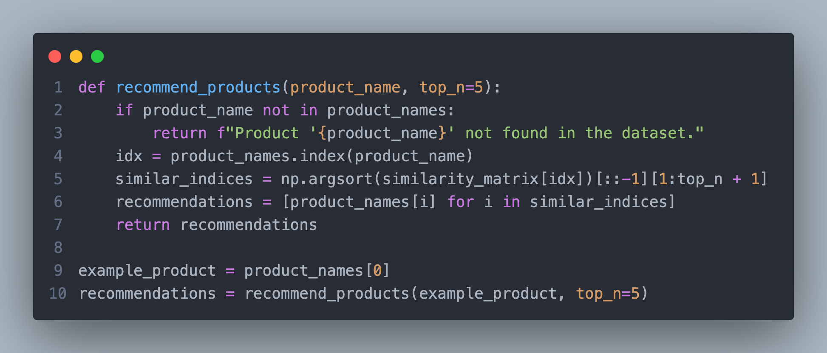
- Defines a recommendation function that finds similar products for a given product based on the similarity matrix.
- Returns the top n most similar products (excluding the queried product itself).
- Example recommendations are generated for the first product in the dataset.

Output:
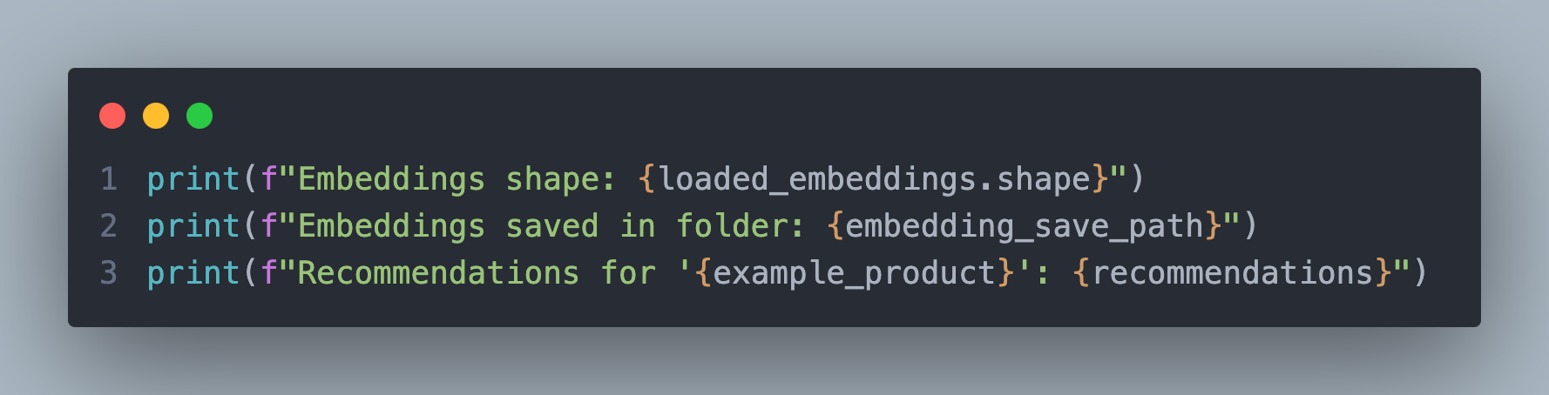
- Prints the shape of the loaded embeddings, confirming successful computation.
- Displays the folder where embeddings are saved.
- Outputs recommendations for the example product.
This modular and efficient approach ensures scalability, accuracy, and easy integration of product similarity and recommendation functionality.

